2022 Membership Application Form

Company:
Contact:
City:
Address:
Telephone:
Email:
Website:
Facebook/Social Media Accounts:
How can the West Nipissing Chamber help you get the most out of your 2023 Chamber membership?
Please send your business logo to admin@westnipissingchamber.ca
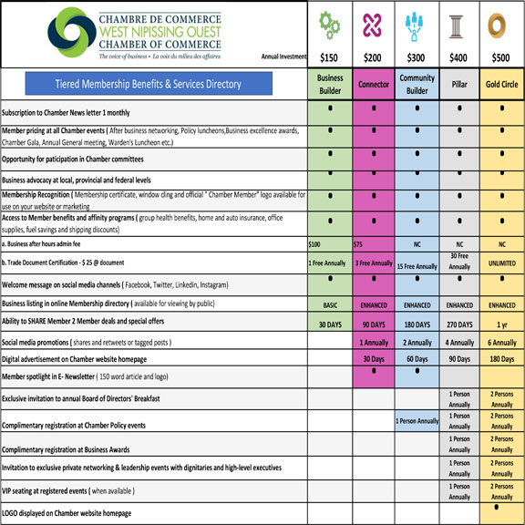
*I will allow my basic business information to be displayed on the WNCC membership list, website and given as customer referrals (under the Privacy Legislation Act, we require your permission)

To learn more about your needs, the
WNCC has put together a brief survey attached to this form. We ask that all Chamber Members participate!

Member Satisfaction Survey

Why did you choose to sign up for the Chamber in 2022?

Do you follow our monthly newsletters? If so, what content would you like to see more of?

Which of the following chamber programs would provide a benefit to you or your business?

Business After Hours/Networking Events Workshops and Tutorials (Online and In-person) Assistance with Loans and Grant Opportunities Advertising Opportunities
Are you currently involved in any of our organization’s committees? (Governance, Special Projects, Membership and Marketing, Finance, Feast on the Farm).
Yes No

Would you be interested in joining a committee in the future? if so please specify

On a scale of 1-10, how likely or unlikely are you be to recommend the Chamber of Commerce to another local business?
10 (very likely)

Additional Comments:

